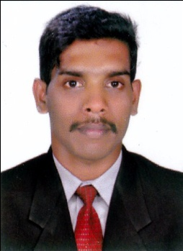
CURRICULAM VITAE

NIJITH T.U
Kerala, India
Mob: +91 97 45 15 37 97
Nijithtualone333@gmail.com

OBJECTIVES
To seek placement where my qualification and experience will be beneficent to the enterprise and myself where I can prove my ability through hand and brain work, with a high degree of integrity, loyalty and team spirit.

STRENGTHS
-Good knowledge in different type of material and various type of production planning,process planning and control
-Basic skill in CAD Master in DTP
-Self motivated excellent communication skills
-Team player and Leadership skills

SKILLS AND ABILITIES
-Production planning and process planing
-Metrology
-DTP

PERSONAL DETAILS
Father’s Name : Unnikrishnan T.K
Nationality : Indian
Gender : Male
Date of Birth : 25/07/1993
Marital Status : Unmarried
Permanent Address : Thoomatt House
P.O Santhipuram, Kodungallur
PASSPORT DETAILS
Passport Number : M1067939
Date of Issue : 20/08/2014
Date of expiry : 19/08/2024
Place of issue : Cochin

PHYSICAL STATUS
Height : 173cm
Weight : 70kg

QUALIFICATIONS
SSLC
PLUS TWO
DIPLOMA IN ELECTRICAL ENGINEERING
QC AWS
NDT ASNT LEVEL II

EXPERIENCE
THREE YEARS EXPERIENCE IN ELECTRICAL SUPERVISER IN CONSTRUCTION COMPANY
ONE YEAR EXPERIENCE IN MEP ENGINEERING IN REPUTED CONSTRUCTION COMPANY KOCHIN
EXPERIENCE IN BPCL KOCHIN IN THREE MAJOUR OIL AND GAS PROJECT
COMPUTER AWARENESS
DTP

LANGUAGE KNOWN
Language | Speak | Write | Ability to manage
Malayalam | Yes | Yes | 99%
English | Yes | Yes | 80%
Hindi | Yes | Yes | 60%

DECLARATION
I hereby solemnly declare that the all above information’s are true and correct to the best of my knowledge and belief. If at any stage, information furnished by me is found to be false or incorrect, I will be liable for disciplinary action or termination of service as deemed fit.

Place : Kodungallur NIJITH T.U

